***Section* 1.6 – Surface Area**

Consider a curve  on an interval , where *f* is a nonnegative function with a continuous first derivative on . Revolving the curve about the  to generate a surface of revolution.

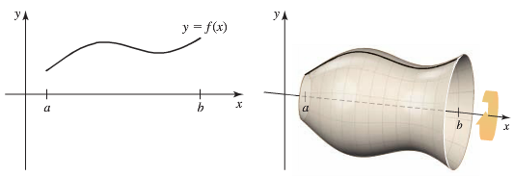

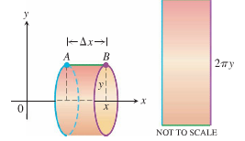

Consider the graph of  on the interval , where  and . When this line segment is revolved about the , it generates the surface of a cone of radius *r* and height *h*,

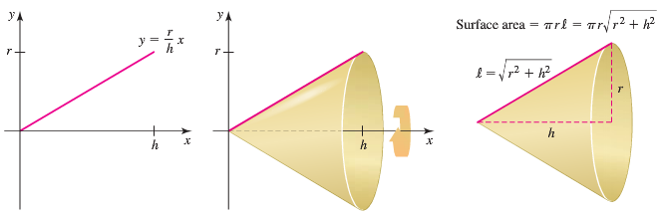

The surface area of a right circular cone, excluding the base, is 

One way to derive the formula for the surface area of a cone to cut the cone on a line from its base to its vertex. When the cone is unfolded it forms a sector of a circular disk of radius . So the area of the sector, which is also the surface area of the cone, is 

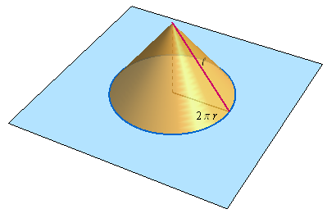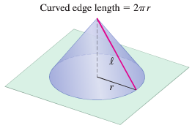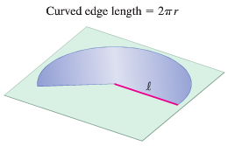

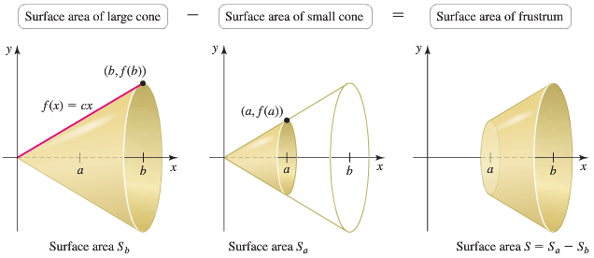

***Definition***

If the function  is continuously differentiable on [*a, b*], the area of the surface generated by revolving the graph of  about the is



***Example***

Find the area of the surface generated by revolving the curve , about the .

***Solution***





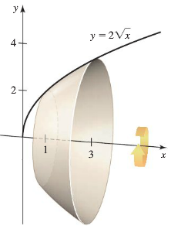 

















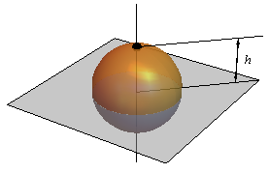***Example***

A spherical cap is produced when a sphere of radius *a* is sliced by a horizontal plane that is a vertical distance *h* below the north pole of the sphere, where . We take the spherical cap to be that part of the sphere above the plane, so that *h* is the depth of the cap. Show that the area of a spherical cap of depth *h* cut from sphere of radius *a* is .

***Solution***

To generate the spherical surface, we revolved the curve  on the interval  about the .

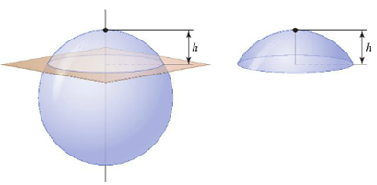

The spherical cap of height *h* corresponds to that part of the sphere on the interval  for 



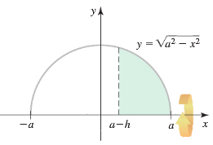











***Surface Area for revolution about the y-axis***

If  is continuously differentiable on [*c, d*], the area of the surface generated by revolving the graph of  about the *y*-axis is





***Example***

The line segment , is revolved about the *y*-axis to generate the cone. Find its lateral surface area (which excludes the base area)

***Solution***





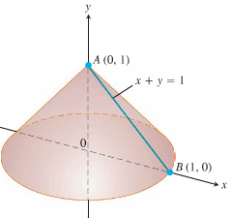











***Example***

Consider the function 

Find the area of the surface generated when the part of the curve between the points  and  is revolved about .

***Solution***

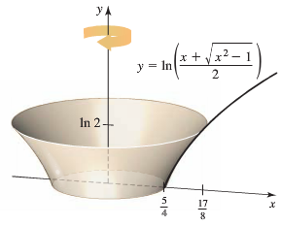































***Exercises Section* 1.6 – Surface Area**

1. Find the lateral (side) surface area of the cone generated by revolving the line segment, about the *x*-axis. Check your answer with the geometry formula



1. Find the lateral surface area of the cone generated by revolving the line segment , about the *y-*axis. Check your answer with the geometry formula



1. Find the lateral surface area of the cone frustum generated by revolving the line segment , about the *x-*axis. Check your answer with the geometry formula



1. Find the lateral surface area of the cone frustum generated by revolving the line segment , about the *y-*axis. Check your answer with the geometry formula



Find the area of the surface generated by revolving the curve about the 

|  |  |
| --- | --- |
|  |  |
|  |  |
|  |  |

Find the area of the surface generated by revolving the curve about the 

|  |  |
| --- | --- |
|  |  |
|  |  |

1. A right circular cone is generated by revolving the region bounded by , , and  about the . Find the lateral surface area of the cone.
2. A right circular cone is generated by revolving the region bounded by , , and  about the . Verify that the lateral surface area of the cone is 
3. Find the area of the zone of a sphere formed by revolving the graph of , about the 
4. Find the area of the zone of a sphere formed by revolving the graph of , about the . Assume that .
5. Find the area of the surface generated by part of the curve  between the points  and  
6. Find the area of the surface generated by part of the curve  between the points  and  
7. Find the area of the surface generated by  between the points  and  
8. Find the area of the surface generated by 
9. Find the area of the surface generated by 
10. At points on the curve , line segments of length *h* = *y* are drawn perpendicular to the *xy*-plane. Find the area of the surface formed by these perpendiculars from 

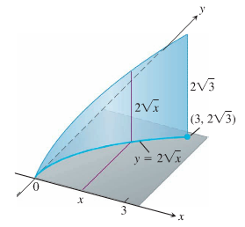

1. Find the area of the surface generated by 

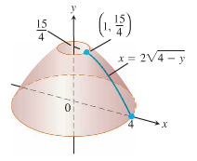

1.  (Hint: Express  in terms of *dy*, and evaluate the integral  with appropriate limits.)
2. Find the area of the surface generated by 

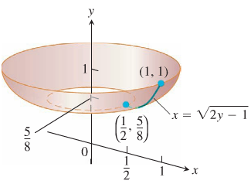

1. Find the area of the surface generated by revolving the curve  about *y*-axis

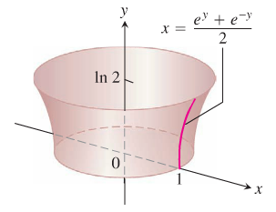

1. Did you know that if you can cut a spherical loaf of bread into slices of equal width, each slice will have the same amount of crust? To see why, suppose the semicircle  shown here is revolved about the *x-*axis to generate a sphere. Let *AB* be an arc of the semicircle that lies above an interval of length *h* on the *x-*axis. Show that the area swept out by *AB* does not depend on the location of the interval. (It does depend on the length of the interval.)

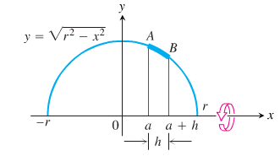

1. The curved surface of a funnel is generated by revolving the graph of  on the interval  about the . Approximately what volume of paint is needed to cover the outside of the funnel with a layer of paint 0.05 *cm* thick? Assume that *x* and *y* measured in centimeters.
2. When the circle  on the interval  is revolved about the , the result is the surface of a torus, where . Show that the surface area of the torus is .
3. A 1.5−*mm* layer of paint is applied to one side. Find the approximate volume of paint needed of the spherical zone generated when the curve  on the interval  is revolved about the . Assume *x* and *y* are in *meters*.
4. A 1.5−*mm* layer of paint is applied to one side. Find the approximate volume of paint needed of the spherical zone generated when the upper portion of the circle  on the interval  is revolved about the . Assume *x* and *y* are in *meters*.
5. Find the surface area of a cone (excluding the base) with radius 4 and height 8 using integration and a surface area integral.
6. Let  and let *R* be the region bounded by the graph of *f* and the  on the interval 
7. Find the area of the surface generated when the graph of *f* on  is revolved about the .
8. Find the volume of the solid generated when *R* is revolved about the .
9. Find the volume of the solid generated when *R* is revolved about the .
10. Let  and let *R* be the region bounded by the graph of *f* and the on the interval 
11. Find the area of the surface generated when the graph of *f* on  is revolved about the .
12. Find the volume of the solid generated when *R* is revolved about the .
13. Let  and let *R* be the region bounded by the graph of *f* and the on the interval 
14. Find the area of the surface generated when the graph of *f* on  is revolved about the .
15. Find the length of the curve  on 
16. Find the volume of the solid generated when *R* is revolved about the .
17. Find the volume of the solid generated when *R* is revolved about the .
18. Suppose a sphere of radius *r* is sliced by two horizontal planes *h* units apart. Show that the surface area of the resulting zone on the sphere is , independent of the location of the cutting planes.

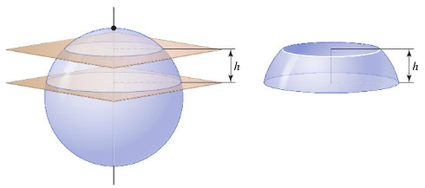

1. An ornamental light bulb is designed by revolving the graph of  about the , where *x* and *y* are mesured in *feet*. Find the surface area of the bulb and use the result to approximate the amount of glass needed to make the bulb.

(Assume that the glass is 0.015 *inch* thick)

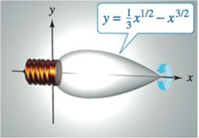

1. The shaded band is cut from a sphere of radius *R* by parallel planes *h* units apart. Show that the surface area of the band is 

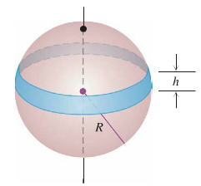

1. A drawing of a 90-*ft* dome is used by the National Weather Service. How much outside surface is there to paint (not counting the bottom)?

